Interview script

If you are interviewing in a tech-rich environment such as a maker space, computer lab, library and so on, start here. Other interviews skip this question.
- What devices in this place do you use?
If you are NOT interviewing in a tech-rich environment, start here.
- This question is about devices that you use in your daily life, wherever that may be. It might be one you own, or one you just use.
a. a desktop computer? Y/N
b. a laptop computer? Y/N
c. a smart phone or cell phone? Y/N
d. a tablet or e-reader? Y/N
e. a gaming console? Y/N
f. a voice activated internet device for instance Alexa or Echo? Y/N
- Do you use any of the devices we’re talking about
a. At work?
b. At school?
c. Elsewhere? Where:
- Now, more generally would you say that you have enough help with using these devices we’ve been talking about, or would you like to have more help. (enough or more)
- Please tell me about a time when you were stuck while trying to do something with one of these devices, and you turned to someone who helped you?
Interviewer prompt as needed to help speaker to explain:
What were you trying to do?
Who helped or tried to help you?
Why did you turn to them for help?
What did that person/s do?
- In general, who do you turn to for help with technology and how do you know them?
Recorder create a list with any description the speaker gives.
- Now, turning things around, have you yourself ever helped someone else with their digital devices?
Recorder enter yes or no.
- (If yes) Tell me about a time when you were helping someone else. I’m hoping you can tell me a story about when this happened.
Interviewer and recorder: Get the details of what they tell you. Prompt them as needed to explain:
Who did you help?
What were they trying to do?
Why did they come to you?
What did you do?
- Please tell me about when you first started using these devices. Why did you start?
- Please tell me about how has your usage or access to these devices has changed over your lifetime? What caused the change or changes?
- Now wrapping up and thinking about the future. What might you like to do in the future with technology?
- OK, last few questions.
Gender, Age, Nationality, Class.
Do you identify as male, female, or something else?
Ask where culturally appropriate, or note your observation
- In what decade were you born?
- How many people live in your house or primary residence?
- Would you describe where you live as:
A big city?
The suburbs or outskirts of a big city?
A town or small city?
A country village?
A farm or home in the countryside?
- How many years of formal education have you completed?
- Please tell us one or two of these that you feel identify you:
your first language?
other languages spoken?
country of birth?
country of residency?
ancestry or ancestries (up to two)?
- What of these have you been doing this past week:
paid work?
education?
self-employed?
unemployed, that is, wanting a job?
permanently sick or disabled?
retired?
community or military service?
housework or at home caring for children or others?
- Please tell me how you feel about your household income at present:
living comfortably?
coping?
finding it difficult
finding it very difficult?
- If you are doing paid work, what category is it from this list? Show the list of jobs, give them a moment to consider, and write down the number that matches what they say. 0-9
Can explain “There may not be a perfect fit to this list, just choose what you think fits best.”
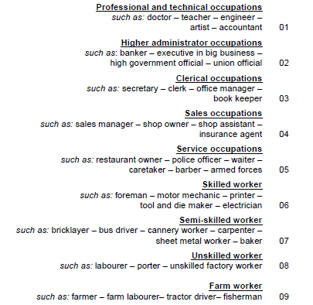
That’s the end of the questions. Thank you very much! Now, can I help you with your phone or computer or anything else? Help them as needed.

